A Journey
Through Korea’s Transformation
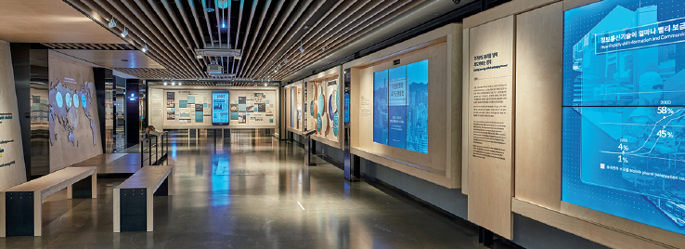

The Global Knowledge Exchange and Development Center (GKEDC) was officially launched in 2018 by the Ministry of Economy and Finance (MOEF) and Korea Development Institute (KDI). The Center is a knowledge hub offering exhibitions, learning programs, and knowledge contents based on the development experience of Korea and other countries.
The International Education and Cooperation Team at GKEDC offers various educational programs targeting international students residing in Korea. The programs offer stories of Korea's economic development through the exhibitions which capture pivotal moments in Korea's modern history in economic, social, and cultural contexts. Also, it includes activities aimed to stimulate mutual exchange of country cases among participants. Especially, given the pandemic situation, GKEDC designed online courses for the international partners.
The Republic of Korea has made one of the most dramatic transformations in a short time period. The Country has transitioned from a resource-poor, low-income nation to one of the most technologically advanced nations in the world. This miraculous journey has been accompanied by challenges and hardships. Our programs will not only give you a chance to witness Korea’s experiences but also to link with the global development agenda.
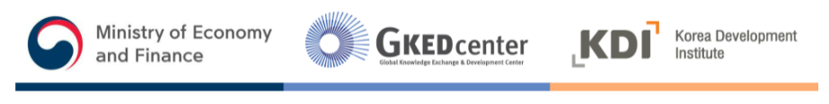
Core Program (Online) : Korea’s Economic Development

A. Overview
- You can participate in a half-day course (3 hours).
- Programs are provided via online.
- International students currently studying at universities in Korea (minimum 10 students per class)
- Free of Charge
- You can apply through your school (First Come First Serve) (https://www.gkedc.go.kr/activity/programView/3113?lang=en_US).

B. Contents
- Learn about the stages of Korea’s economic and industrial development
- Explore the driving forces of Korea’s economic development
- Identify the driving forces of economic development in participants’ countries and share the stories

C. Schedule for online
Program | Time | Contents
Part 1. Opening | 10min | Introduction of GKEDC and Learning Objectives
Part 2. Facilitated Session | 40min | Economic Development Hall Tour and Online Activity
Part 3. Lecture | 40min | Overview of the Driving Forces of Korea’s Economic Development  - What are the driving forces of Korea’s economic development?  - What is the current economic status of Korea?  (Achievements and challenges)
Break (10min)
Part 4. Activity | 60min | Option 1. Case Study and Discussion  Option 2. Analysis of Driving Forces in Participants’ Countries
Part 5. Closing | 20min | Summary of lessons learned &Survey
Total of 3 hours
*Schedule is subject to change.
Core Program (Online) : Korea’s Industrial Development

A. Overview
- You can participate in a half-day course (3 hours).
- Programs are provided via online.
- International students currently studying at universities in Korea (minimum 10 students per class)
- Free of Charge
- You can apply through your school (First Come First Serve) (https://www.gkedc.go.kr/activity/programView/3112?lang=en_US).

B. Contents
- Understand Korea’s industrial development process, its characteristics and its success factors.
- Broaden understanding of industry and explore the role of government policy in industrial development.
- Discuss the current challenges and policy directions for industrial development in participants’ countries

C. Schedule for online
Program | Time | Contents
Part 1. Opening | 15 min | Introduction of GKEDC and Learning Objectives
Part 2. Facilitated Session | 40 min | Industrial Development Hall Tour and Online Activity
Part 3. Lecture | 40 min | Korea's Industrial Development and the Role of Government Policy
Break (10 min)
Part 4. Discussion | 60 min | Analysis of Current Challenges for Industrial Development  in Participants’ Countries
Part 5. Closing | 15 min | Summary of lessons learned & survey
Total of 3 hours
* Schedule is subject to change.
