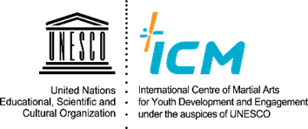
2022 5th AFRICAN MARTIAL ARTS CONGRESS
25th - 28th OCTOBER 2022, ICM, CHUNGJU, KOREA

Photo
(High Resolution)
Registration Form

1. Participant information:
Title | Mr. Mrs. Dr. Prof. Miss/Ms. Madam
First Name
(Middle Name, if applicable)

Surname

Organization / School / etc.
Position (Designation)
Field of Job or Study (Experience/Work)

Country
City
Address (in your country)
Passport Number  (Double-Check!) | (For participants from inside of Korea, no need to fill this part)
Contact Address | Mobile:
 | E-mail (s):
Food (Special Needs)  (Or Accommodation Needs) | (If applicable) Any Allergies or Vegetarianism (or Veganism) / Halal Food etc.
Height and Size of Shoes | cm / mm (This is for your martial arts uniform as a gift)
Field Trip Attendance  (Chungju / Seoul) | Chungju / Seoul(DMZ)  (For participants from outside of Korea are mandatory to participate in both)
Any inquiries or comments
………………………………………………………………………………………………………………………………………………….................…

NB: In registering for this Congress, relevant details (photo/name/address) will be incorporated into a participant list for the benefit of all guests and UNESCO ICM staffs, and also may be made available to parties directly related to the Congress including logistics, supplies, and schedules as well as working partners. Thank you for your cooperation.

