https://www.chronicle.com/article/How-to-Ask-for-a/235968/
ADVICE

How to Ask for a Recommendation
And how to supervise the faculty member writing it
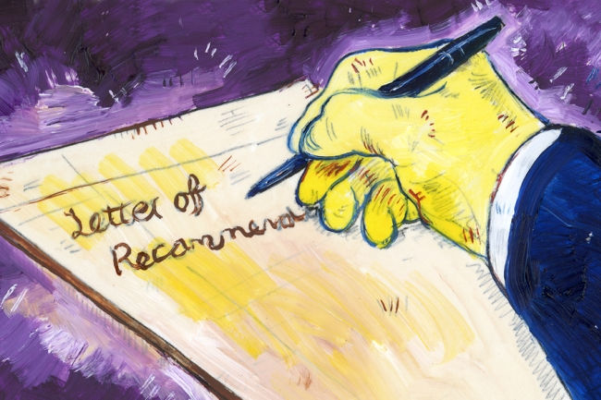Brian Taylor
By Leonard Cassuto APRIL 04, 2016
It seems a simple enough question, and in a way, it is: "Would you write me a recommendation?" The reply will ordinarily be "Yes," and then professor and graduate student head down a familiar path.
But the trip isn’t as simple as it seems. For starters, let’s consider who’s directing it. I may be writing the recommendation, but don’t think I’m in charge. The main responsibility rests with you — the student who’s asking for the letter.
That’s right: You’re guiding this process. When I write a recommendation for you, I’m working for you. Both of us, but especially you, want my letter to be as strong and persuasive as it possibly can be. That means you need to supervise me properly. Here are some guidelines for how to do that.
First, supply me with everything I need. My writerly requirements will vary according to the type of letter you’re asking me to write, but I will always need a copy of your cover letter (for a job request) or project statement (for a grant or fellowship) or personal statement (for undergraduates applying to graduate school). It’s OK to share a rough draft. The point is that I need to know how you’re presenting yourself, so I can craft an approach that complements yours. (See what I mean about you being in charge? You set the rhetorical course.)
Because you’re the one applying, you have to decide on your most persuasive strategy of self-presentation. Of course I want to help you. If you give me a coherent draft of your cover letter or project statement, I’ll advise you on how to make it most convincing. If it’s a polished draft, I’ll help you edit it. But you’re the one who’s making that happen. I’m the one giving help and advice.

How Do I Become an Administrator
We offer here a mix of essays from The Chronicle’s Advice columns (often focused on trends in academic work and life) and from Vitae (focused on practical, how-to advice for early-career academics and administrators). Now in its fourth year, with more than 840,000 members at more than 4,000 institutions, Vitae continues to offer free career-management tools and the best job openings.
- Administration 101: Deciding to Lead
- Finding Out Who’s Got Game
- Don’t Cry for Me, Academia!
- ‘Operation Keep My Job’
- The Small but Cool Moments of Faculty Life
- The Top 5 Faculty Morale Killers
- A Letter to Past Graduate-Student Me
- Teaching Tips for Graduate Students
- Why New Humanities Ph.D.s Should Leave the Country
- The Completion Agenda, Part 5: Your Publishing Plan
So decide what paperwork you should give me to support my task. If you took one of my courses, send me copies of the best writing you did for me. I may have taught you a year or two ago, perhaps longer. If I am to talk in useful detail about your paper or project, I need it in front of me again.
The persuasive force of my letter will lie in its attention to detail. Don’t take for granted that I remember what you did. Even if I do, I won’t recall the details. I may still have your work on file (especially now that we live in a paperless world), but why should you assume that? And even if I do have it, you should save me from having to locate it.
But don’t stop there. Maybe you did related work in a different course or a job that makes you look even more qualified. There’s no way that I can know about that unless you tell me. So send me copies of other work you’ve done if you think they might help. I can always ignore them if they prove extraneous, but I can’t summon them into being if I need them. Better too much potential evidence of your acumen than too little.
Attach all of this — the statement, the writing samples, anything else you want met to include — to a single email so everything is in one place. (And then confirm that I received it.) Simplest is best: One clearly marked virtual package will set me up to do my best work for you.
Direct me. Yes, you need to tell me what to do — or, to put it less roughly, you need to describe what you need from me. Students often think that recommendation writing is a black box whose inner workings they’re powerless to understand or affect. We professors encourage that belief by cloaking what we do in a deliberately mysterious mantle of "confidentiality." (I’ll have more to say about that next month.) Even with all of our fetishistic secrecy, your powerlessness is a fallacy. You’re only powerless if you step away.
ADVERTISEMENT
Let’s say you’re applying for admission to a Ph.D. program and you’re asking me for a recommendation. Such applications require multiple references, usually three or more.
You can make your recommendation requests and then modestly withdraw, but why should you limit your influence that way? Instead, imagine your recommenders as your panel, a group you’ve recruited to advocate for you. Actually, you don’t need to imagine that — it’s an actual fact. So imagine us as a group of musicians, with yourself as the conductor. How can you orchestrate our efforts to your greatest advantage?
To answer, let’s follow this little thought experiment a bit further. Perhaps you did good writing for all of your recommenders, but I taught you in a small class. In that case, you could remind me of your active participation and your excellent oral presentation because you know that of all of your recommenders, I’m best qualified to describe those qualities in you. So make an explicit request: "I was hoping that in your letter, you might be able to emphasize … "
We recommenders welcome your guiding suggestions because we’re working for you. Without specific guidance, I might focus on your writing and give short shrift to something important to your application.
Be clear about deadlines, and give me enough time to meet them. Like every other professor I know, I receive last-minute recommendation requests. Most of us take these in stride and do as well as we can, but that doesn’t mean we’re happy about it. Eleventh-hour labor does not produce my best work.
So manage your application calendar. One of the less-remarked-upon consequences of the increasingly competitive world that graduate students live in is that recommendation season now runs all year round. I have graduate students applying for multiple fellowships who even supply me with spreadsheets with the due dates and destinations for each required letter.
One last thing: Don’t be afraid to remind me if the deadline grows nigh. I usually manage my workload pretty well, but I know that my letter is important to you, and I won’t be offended if you check in to make sure that I didn’t forget about it.
Academe is a culture of evaluation. It binds our community together and comes in many forms — student admissions folders, article and book manuscripts, tenure and promotion applications, classroom visits, grant and fellowship applications, and reams of other assessment work. You could say that evaluation is what we all have in common.
Given that fact, graduate students — and undergrads, too — are entitled to have professors write them recommendations. The system requires those letters, and unless you’re doing something silly, like asking me for a recommendation when I gave you a C, I expect to write your letter for you.
I mention this "default yes" position because students often ask for recommendations as though they’re begging for a special favor. It’s not a favor. It’s part of my job — and one of the more rewarding parts of it, in fact, because I get to see recommendations bring good things into students’ lives. So don’t feel guilty about asking for a letter.
But it’s a mistake to assume that recommendations are only my job. They’re a bigger part of yours — and you’re the one who’s employing me. Maybe you’re not comfortable thinking of our relationship like that. After all, it’s true that I’m your boss in some important ways: I give the grades, and I approve the thesis or dissertation. But there are books galore that explain how to manage your boss. Managing your adviser is no exception. It’s an important skill, and how to ask for a recommendation is only one example of it.
It has been often said — by me, anyway — that you are the CEO of your own graduate education. Recommendations offer no better example of that. Now go out and take charge.
ADVERTISEMENT
Leonard Cassuto, a professor of English at Fordham University, writes regularly about graduate education in this space. His new book is The Graduate School Mess: What Caused It and How We Can Fix It, published by Harvard University Press. He welcomes comments, suggestions, and stories at lcassuto@erols.com. Twitter handle: @LCassuto.

READ MORE

